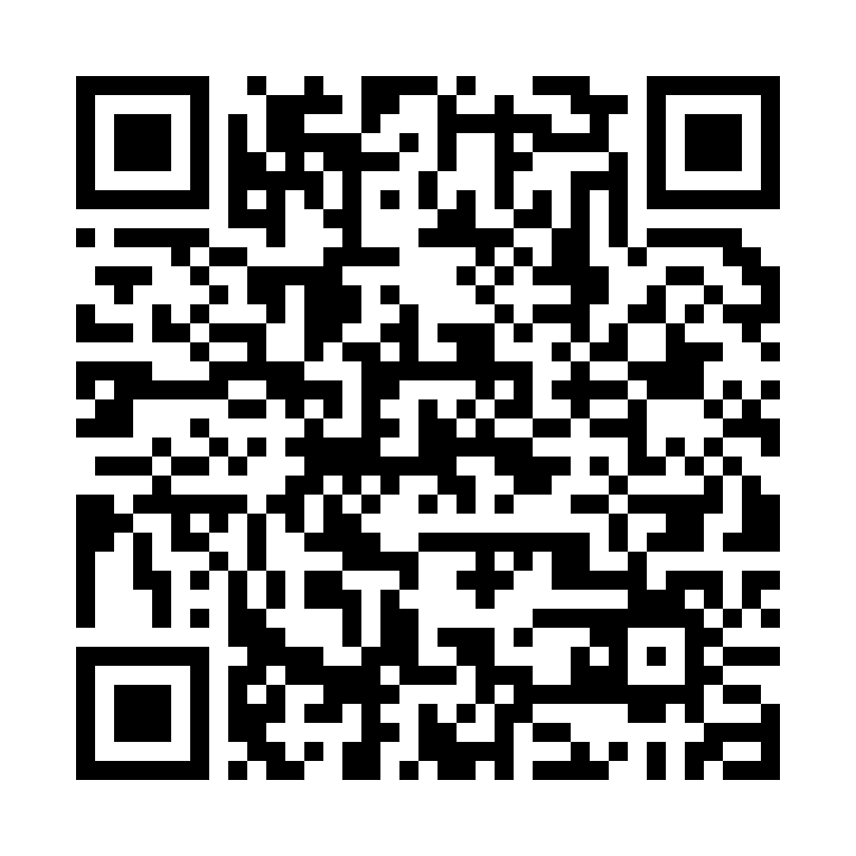
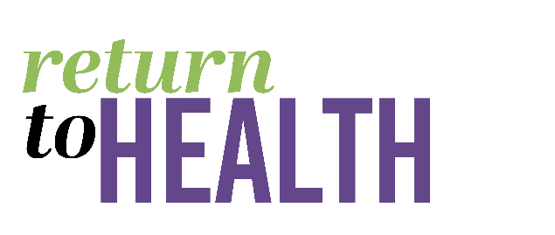
OFFICE OF THE SUPERINTENDENT
5735 47th Avenue ● Sacramento, CA 95824

Jorge A. Aguilar, Superintendent

BOARD OF EDUCATION  Christina Pritchett  President  Trustee Area 3  Lisa Murawski  Vice President  Trustee Area 1  Darrel Woo  2nd Vice President  Trustee Area 6  Leticia Garcia  Trustee Area 2  Jamee Villa  Trustee Area 4  Chinua Rhodes  Trustee Area 5  Lavinia Grace Phillips  Trustee Area 7  Isa Sheikh  Student Board Member |  | Dear Parent,  Sacramento City Unified School District (SCUSD) is pleased to offer free and voluntary COVID-19 screening testing for all students and staff.  Parent/guardian consent is required to provide testing for students under 18 years old. Consent is given one time when registering your student for the testing program.  SCUSD is utilizing two types of COVID tests. Both tests are self-administered nasal swabs, which means individuals use a long soft cotton swab to gently circulate in each nostril. These tests are simple enough for children to do themselves with a person instructing and observing.  - PCR Testing is widely used and known as the most reliable test. Results are provided within 24-48 hours.  - Rapid antigen tests/BinaxNOW provides results within 15 minutes, however any positive test results must be confirmed with a PCR test.  The surveillance testing program is designed to screen people without symptoms that might be carrying the virus. Surveillance testing will be offered on a regular basis depending on Sacramento county’s risk level tier assignment as designated by the California Department of Public Health. Please see the SCUSD Reopening Dashboard Testing FAQs and the SCUSD Return to Health Plan for further details about testing.  Registration:  Staff or students register for testing using a unique link or QR code for their site:  Caleb Greenwood Student Registration:  https://home.color.com/covid/sign-up/start?partner=34674396033815students  You only need to register one time. When you arrive at the test site testing staff will confirm your registration on the Color application.  Result times vary by tests:  - PCR Tests are packaged and delivered to a drop site nearby. The results are sent directly within 24-48 hours to the individual or parent/guardian, SCUSD Health Services designee, and county and state public health agencies. If a staff or student test positive, the adult or the student's guardians will be notified via a text and via email they have used for registration  - Rapid antigen tests are conducted on site with results within 15-30 minutes.  Privacy and Security:  Personal health information and test results are confidentially stored in the Color software application. Your information and results will be shared with SCUSD Health Services, and with state and county agencies for public health contact tracing purposes. You may view COVID terms of service, Notice of Privacy Practices, COVID HIPAA authorization, and COVID informed consent to learn more.  Self-collection:  To collect the specimen, the individual will place a swab, similar to a cotton swab/Q-Tip, inside of the tip of the nose.  How to swab video here Helping children self-swab! -video  Why we test:  -The results of this test can help keep your school community healthy and safe.  -The results of this test can help limit the spread of COVID-19 to your family and your community.  FAQ:  What is COVID-19?  COVID-19 is a disease caused by a virus known as SARS-Cov-2. The virus can have no  symptoms or cause mild to severe respiratory illness. People who are infected can have  symptoms that include cough, shortness of breath or difficulty breathing, fever, chills, muscle pain, headache, sore throat, nausea or vomiting, diarrhea congestion or runny nose, fatigue or loss of taste or smell.  Why was I (or my child) tested?  You (or your child) was tested as part of routine screening at school to detect cases of COVID-19 to help avoid the spread of the virus. This screening program does not replace the other important safety measures that help keep the school community safe, such as health screening, wearing face coverings, physical distancing, frequent handwashing, disinfecting high contact areas and maintaining stable groups.  What are the known potential benefits and risks of the test?  Potential benefits include that the results of this test can help keep your school community healthy and safe. The results of this test can help limit the spread of COVID-19 to your family and your community. Potential risks include possible discomfort or other complications that can arise from sample collection and possible incorrect test result.  How will I know when my results are ready?  You will receive a text and email at the phone number and email you provided. You can also visit color.com/covid-test to check if your results are ready. You’ll need to enter your date of birth and the test barcode found on your test kit card.  Expected turnaround time?  Turnaround time is the usual number of hours from the time a specimen is received at the laboratory to when the result is released. Results for PCR tests are provided within 24-48 hours. Results for the rapid antigen test/BinaxNOW are provided within 15 minutes.  What do I do if I’ve lost my barcode?  Please do your best to keep your barcode. Losing it may delay access to your results. Some people take a photo of it with their phone, just in case. If you lose your barcode, please contact Color Support for assistance at 833-594-1825 or mycovidtest@color.com.  Who should I contact if I have more questions or if I need help accessing my results?  Please contact Color Support at 833-594-1825 or mycovidtest@color.com.

