First Day of School Information

Welcome to Caleb Greenwood School! We are looking forward to a wonderful year with your child in our Kindergarten class. We would like to share some information that will help our opening go smoothly:

- School begins at 7:55 am and ends at 11:45 am. (Arrival between 7:45 -7:55 am.)
- Parents need to be ready to drop their child off on the first day. We ask parents not to linger outside the rooms. Children make a much better transition to school when the “good-bye” is short, sweet, & brief.
- We need each child to bring a backpack to school daily. Be sure to write your child’s name on the backpack. PLEASE, LABEL ALL OUTERWEAR, too!
- Typically, your child will bring home and return a blue “Kinder Folder” every day of the week, so make sure the backpack is large enough to fit a standard size folder.
- We will provide snack on the first day of school. Following our school wide “Wellness Program”, parents will provide their own child with an individual healthy snack each day, beginning on the second day.
- Kindergarten students do not eat lunch at school unless they attend our 4th R, the after-school daycare program. FREE sack lunches will be available to all students at our 11:45 am dismissal.
- When picking up your child after class, we ask that you wait outside the specific exit gate. We will dismiss students one at a time. Be patient. Never call your child to come to you from the line of students.
- Make sure the teacher and your child know what he/she is doing after school. A lot of anxiety is caused when students are not sure if they need to have someone pick them up, or catch the school bus, or go to 4th R. Please notify your child’s teacher of any schedule changes. Remember that an email to your child’s teacher the night before or a note in your child’s Kinder Folder is a good way to communicate.
- Please fill out the Kindergarten questionnaire that will go home in your child’s Kinder Folder on the first day and return ASAP so that we can begin to learn more about your unique child.

We are looking forward to seeing you and your child on Thursday, September 2!

The Kindergarten Teachers
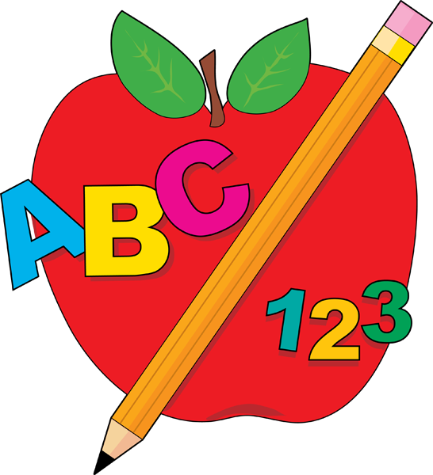 Mrs. Cherry, Mrs. Le, and Ms. Kitowski
This Photo by Unknown Author is licensed under CC BY-SA-NC
This Photo by Unknown Author is licensed under CC BY-SA-NC

